Game Planning document for “Eternal Crossin”
Game Title: “Eternal Crossin"
Genre: Puzzle 2.5D
Platform: PC
Target Audience: 12+
Setting: dream - physical form vs afterlife
YouTube link: https://youtu.be/GXo9iTa6DVU
This is a 2.5D puzzle platform game. The game is very alike to the Ankh symbols from ancient Egypt. Still, my 2.5D puzzle prototype game represents at the same time as battle out of the physical form and the afterlife, as it is thought that one's outside journey is simply one phase of eternal life by challenges by jumping over or avoiding danger as the ground within as water and fire. In 2.5D games speaking, the combination of 2D gameplay mechanics and 3D visuals creates a unique gaming experience that may be both visually engaging and technically challenging. According to a study on developing immersive 2D world images, the design approach includes balancing creative elements with gaming mechanics to promote player participation. Eveliina Aalto Creating immersive 2D world visuals for platform games – Skytails Post-Mortem, [page 20]. Accessed on 06/11/2024 at https://aaltodoc.aalto.fi/server/api/core/bitstreams/ea399ff5-b23b-45f3-a010-03cef8c46844/content
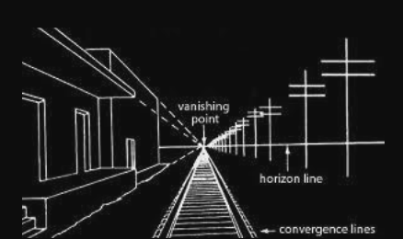
Another sector for designing in my most important core design is speaking as a viewpoint that focuses on creating the appearance of depth in 2D areas. Filippo Brunelleschi developed linear perspective, a numerical method for creating realistic coordinates in two dimensions. In parallel lines, the horizon line, and vanishing points represent a decrease in an object's size as distance increases Britannica. (2014, April 21). at Perspective. Retrieved from Britannica: Accessed on 06/11/2024 at: https://www.britannica.com/art/perspective-art that points out that narrowing enhances the perception of distance as this is important for the player experience for the game I have designed. As shown on the right. Oksanen, (2014)Game Mechanics in the Design of a Collaborative 3D Serious Game.
Emotion in Video Games
Emotions play an important role in video game participation in general, and a game's ability to trigger feelings such as excitement, anxiety, or joy may greatly enhance the player experience. Based on the research, video games can expand players' emotional range, helping their emotional development and giving a richer engaging experience. Shinkle, E. (2008). Video games, emotion and the six senses. Media, Culture & Society, 30(6), 907-915. accessed on 6/11/2024 https://doi.org/10.1177/0163443708096810 . My game focuses on the anxiety, and fear of jumping over or not touching the ground at all.
Game Mechanics in Puzzle Games
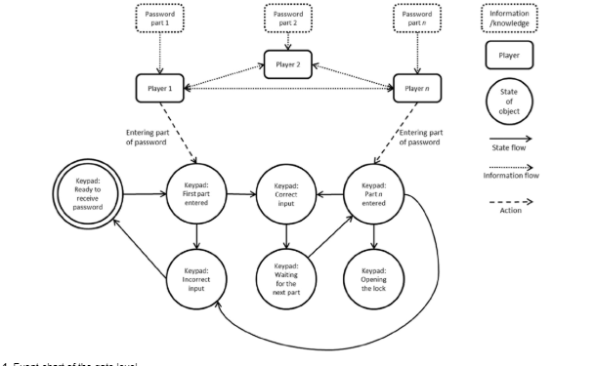
Strong game mechanics are essential for puzzle games due to the control of how challenges are presented and solved. A study on game mechanics highlights the value of creating puzzles that are both tough and rewarding to keep players interested and encourage problem-solving skills. “For example, one player might enter the complete password, but that individual still needed to obtain the necessary information from other members of the group via conversation (flexible tactics). If participants made any mistakes when entering the code, they had to start over. In the diagram. Show how the players' tasks influenced the keypad”. timing, pushing the button to have a trigger to jump on to, and running away from the ball, for these the player makes problems and how to overcome them by solving skills come to be very useful.
Player Experience
The ease of use, storyline, and gameplay interaction all contribute to the overall player experience. Understanding and improving player experience can result in increased levels of engagement and satisfaction. The "Player Experience" study stresses the need to focus on components that support desired experiences, such as story logic and gameplay balance. “Serious Games. In: Dörner, R., Göbel, S., Effelsberg, W., Wiemeyer, J. (eds) Wiemeyer, J., Nacke, L., Moser, C., ‘Floyd’ Mueller, F. (2016).. Springer, Cham. Accessed on 06/11/2024 at: https://doi.org/10.1007/978-3-319-40612-1_9”. To improve the player experience, a great 2.5D puzzle platformer game requires an emotional connection, realistic design, and skills developed as a system. Each of these components works together to produce a game that engages players throughout gameplay and generates the desired feelings. In my game, I want the player to want to do it again, again to have good gameplay from the beginning to the end of the demo. As these connections are based on this source, I can input a rewards system to escape from the “hell” sector at the end of the game. The summary of systems that can do satisfaction challenges, and achievements to enjoy for the player to enjoy the demo that I am making for them. For this speaking my target is for the target player to experience awareness of player actions as feelings. Towards the character and the game for itself.
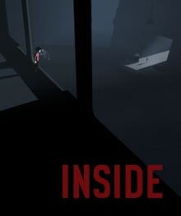
Inspirations
Name of Inspiration (citation): INSIDE, Video Game (AL) PlayDead, release date: 29/06/2016, accessed 14/11/2024 at: https://store.steampowered.com/app/304430/INSIDE/
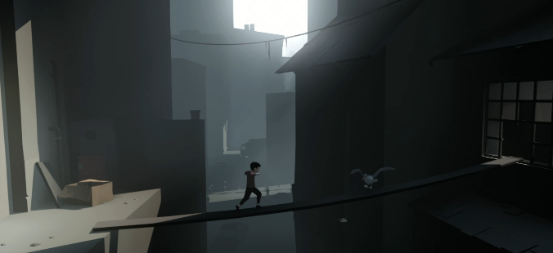
Key scene or mechanic (Description): My first Inspired game is Inside, a surreal, dark-themed 2.5D puzzle platformer with an unclear boy as the main character Like Inside, the game focuses on environmental storytelling and offers an immersive, thoughtful experience where quiet and carefully enhance tension and mystery. For example, a player in my 2.5D game was jumping over or running over a wooden platform to the other side or a bridge from one side to the other side as well as seen in the right picture. The inside inspiration for my 2.5D is several things such as a memorable journey as I played the video game itself, this has been drawn inspiration for creating my 2.5D game that mixes amazing atmospheric storytelling, clean yet striking design, and unique gameplay to produce an original but fascinating player experience. when I play the game itself, I feel enjoyment throughout from the beginning to the ending which was quite a mix of emotions and feelings of the game.
Critical Source used to explain theory or concept: https://www.theseus.fi/bitstream/handle/10024/119612/Thesis%20-%20Toni%20Minkkinen.pdf
In this article “: Basics of Platform Games by Minkkinen Toni” it focuses on the core concepts of platform games, such as how players avoid hazards by jumping and running. It gives fundamental learning on how 2.5D games manage hazards and character resets, which is essential for game design and my video game as well.
Critical Breakdown: The setting is mostly a single colour, with occasional bursts of colour used to highlight the boy and essential interaction elements. The setting is dark and simple, with little dialogue, centring instead on visual clues, sound effects, and rare music to convey the narrative and emotional theme. As a kid explores this strange universe, players must solve puzzles and overcome barriers by interacting with the environment and items. The gameplay emphasises natural movement such as walking, running, climbing, and swimming. This uses the boy's physical ability to overcome the challenges offered by the world.
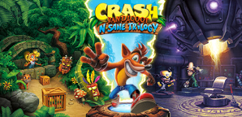
Name of Inspiration (citation): Crash Bandicoot™ N. Sane Trilogy, Video Game (AL),
Vicarious Visions, Iron Galaxy Publisher: Activision released 29/6/ 2018. Accessed 14/11/2024 at: https://store.steampowered.com/app/731490/Crash_Bandicoot_N_Sane_Trilogy/
(right image) where Crash Bandicoot dies and flies to heaven with wings attached.
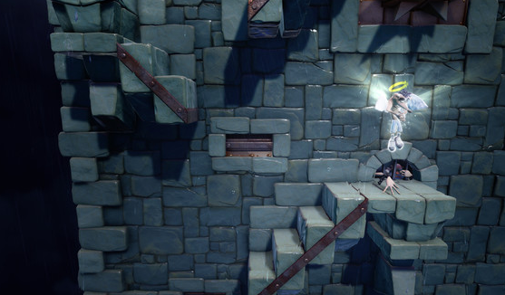
Key scene or mechanic (Description): The core mechanic of my 2.5D game, like Crash Bandicoot N. Sane Trilogy, is navigating dangerous areas by jumping over or avoiding hazards such as water and fire, which serve as symbols for everlasting danger or obstacles to living. However, the deeper focus in my video game is on the journey as a stage of eternal life. The challenges—represented by barriers such as water (often symbolising the flow of life or emotional depth) and fire (as often telling a loss, elimination, or tests) are metaphors for the difficulties and growth one goes through on the journey of a lifetime.
Critical Source used to explain theory or concept for Crash Bandicoot™ N. Sane Trilogy: https://www.proquest.com/openview/76bfe93ea9600b7ac8fe955e7908df2a/1?pq-origsite=gscholar&cbl=18750&diss=y
Audio-Visual Style in Video Games: This article, analyses the basic principles of video game design, including how early games paved the way for today's systems. While this does not especially discuss Crash Bandicoot, it covers the important function of audio-visual elements and user interaction in creating complete in-games, which are essential for understanding game mechanics such as jumping and avoiding hazards in my 2.5D platform game, which is very important.
Critical Breakdown: Crash Bandicoot N. Sane Trilogy is a series of remasters for the original three games: Crash Bandicoot, Cortex Strikes Back and Warped. In each game, Crash Bandicoot navigates in several levels to prevent Doctor Neo Cortex from taking over the entire world. Crash, like the original games, defeats enemies by spinning and jumping, smashing boxes, and collecting treasures like Wumpa Fruits, additional lives, and protective Aku masks. The trilogy introduces additional features across all three games, including uniform checkpoints, pause menus, and save systems, such as individual and automated saving or time trials.
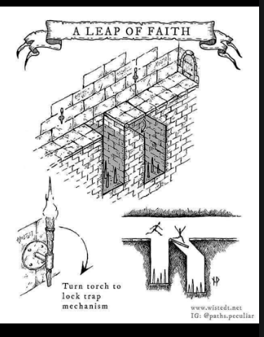
Key Design Principle Used
Theoretical Source: Paths. Peculiar. (4AD) (4th January 2020) accessioned on 11/11/2024 at: https://www.instagram.com/p/B66MFhABDfB/
Critical Discussion (Why?): In the overall setting of my 2.5D game, the "Leap of Faith" trap exhibits essential design ideas linked to environmental storytelling, player agency, and the balance of difficulty and displeasure. The trap presents a layered constraint system in which the player faces not one, but two distinct hazards each requiring a unique level of awareness and action. The trap tricks the players' perceptions by giving what appears to be an easy challenge, only to disclose a hidden danger as below, producing a sense of disloyalty and increased tension in the game. This type of trap can make players doubtful and cautious in the next encounters, changing their point of view and attitude to similar scenarios within the level (s) in the game itself.
The first pit is a simple task that may be solved with appropriate time and without burden. However, the second pit, hidden below as a pressure-sensitive trapdoor, adds issues and risks to challenging the player to adapt to the unknown hazards and predict future environmental changes. This design pushes players to think critically about their actions—whether to hurry through quickly or approach carefully, by reflecting on an overall loadout and possible dangers. The goal is to develop a sense of realism by making the player feel as if they are interacting with an environment that responds according to their actions. Therefore, in carefully combining immediate danger with the prospect of hidden traps, one of my goals is to create both a sense of accomplishment and a drive to explore with more awareness, making every action more meaningful and the gameplay experience broader.
Core Mechanics including movement
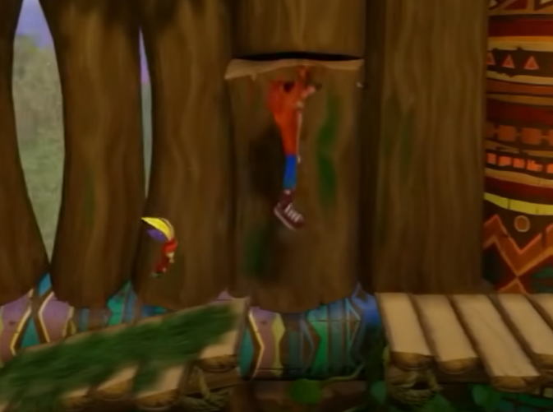
The Crash Bandicoot: N. Sane Trilogy is a remastered collection of the first three Crash Bandicoot games, which became renowned in the platformer genre. This trilogy has many updates from the traditional gameplay with improved graphics and music, bringing Crash's colourful world to life. Players control Crash as he jumps, spins, and avoids numerous hazards over different levels loaded with obstacles and foes. This gameplay mechanism of crossing hazardous passageways is quite like the basic premise of my game, in which the protagonist must expertly hop over or avoid numerous dangers. The captivating challenge of timing and precision is a shared standard that attracts players.
Level Design - layout sketches
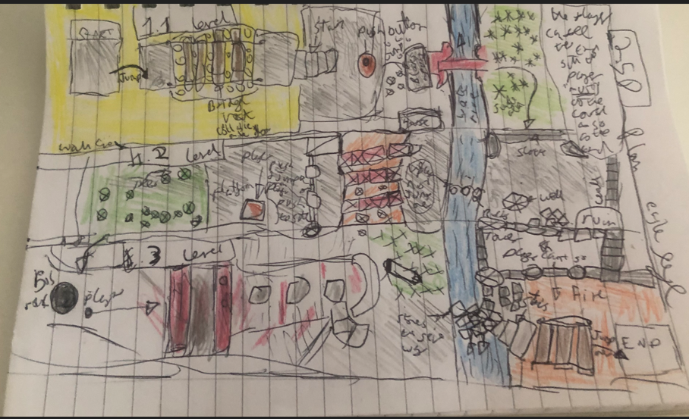
1.. sketch (paper version)
This is the idea, for my first paper level design as used for this sketch, which focuses on different types of levels such as in the 1.1 level. This is only a planning stage which its focused in the bird' eye point of view. For this, a player jumps over from the start to the 1.3 level. At the beginning of the level, the player must jump over the start to the cube where the player must cross the wooden bridge, but the bridge collapses and the stand on it for too long like 3 seconds the player falls into the circle which is a trigger point which resets the level. Then the player walks downstairs and then pushes the button (a trigger point) where a block rises so the player can "reach out” to jump in a clear (if not the player will jump and kill itself and reset from the beginning of the level). Then there is a blockage by the river which the player must cross the bridge (another hazard sector). The player must cross the bridge, if not the player will either fall out (another hazard zone). Therefore, the player goes into the forest and then out to stairs that will start the next level i.e. checkpoint.
(1.2) In this area ideally a ruin that the player can either explore or continue the player's journey (such as looking at the well, houses etc) after that the player jumps over the rocks in the river to the other side, then the player must choice “meaningful choices “some that will be good to go, or some will be sink. After that the player must push the doors to go though also that the player must push the big platform to able to reach out to the next sector in the level, the forest part which ended here.

Finally, last checkpoint (1.3) the player drops down into the area where the is a chase scene where the player must run away from the ball which is behind the player (another hazard) and jump over some wood planks (odd ones which are another hazard sector) and then the rocks as well after that. If the player reaches the chairs in time the ball will stop at the end of the siding where the ball cannot continue. The player goes downstairs where there is a set of rocks or stones and then the player jumps over the bridge made with wooden planks and jumps to reach the end of the level. The End.

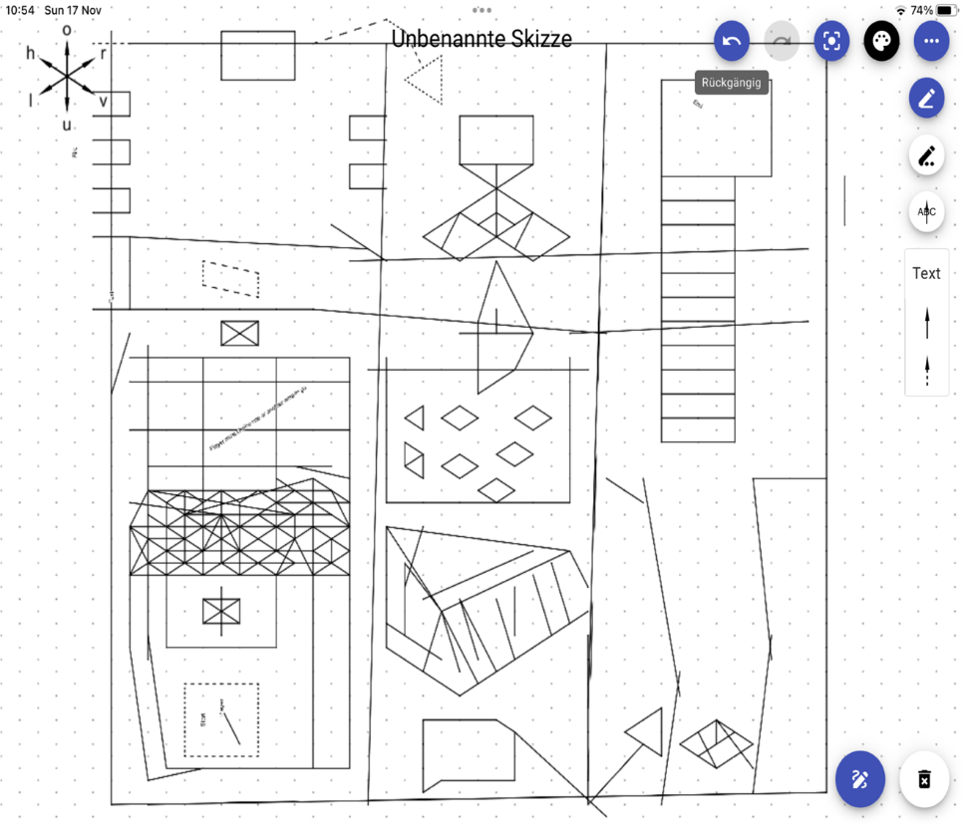
2. sketch (Aisome Apple App)
figure 1.1

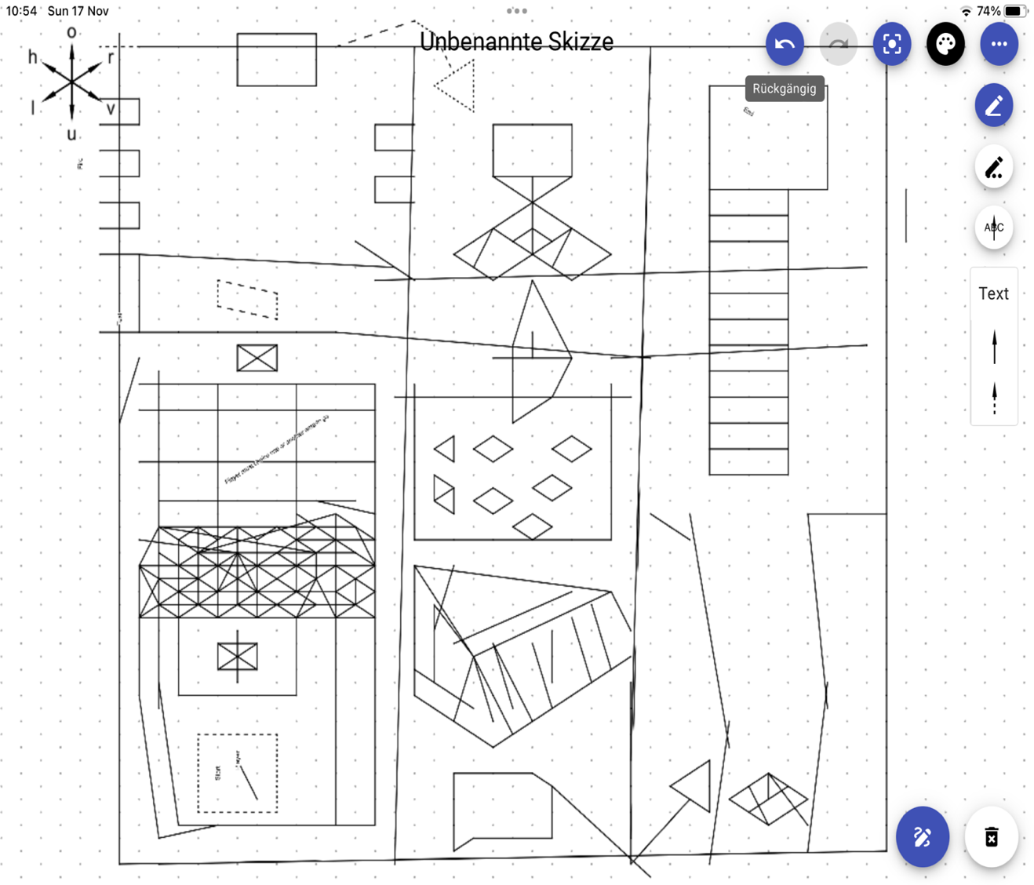
Another sketch is different to the first one I use an Apple app called Aisome, figure 1.1, where the player starts at the bottom of the map, and the player jumps over which is around the start this can be water, fire or other hazardous areas. (if the player misses time, the player resets itself to each checkpoint) the is a lever from which all the blocks come up (wooden platforms) the player must choice in which one to stand on or break up into small pieces (hazard zone) and then another one which is rocks as well.
figure 1.2
figure 1.2, Then the player stands on the push button and a hidden rock comes out of the river. Then the player must run across the pathway where (hazard) fire spits out of the small tunnels which if the player stands on it or avoids will start at the beginning of the level. The next level is a switch one is correct or the other is wrong so the player must choose as a meaningful choice, then the player jumps over, and stepping stones. Then, this part of the laser sector avoids the lights which is an automatically synchronised system. (hazard zone) then the player jumps over to the next checkpoint of the level.
figure 1.3

figure 1.3, The player slides down into this area where there is a chase scene, and the player must run away from the ball that is behind the player (another hazard). Up the stairs and cross the rocky bridge and end of this map. The end.

3. sketch (Paint)
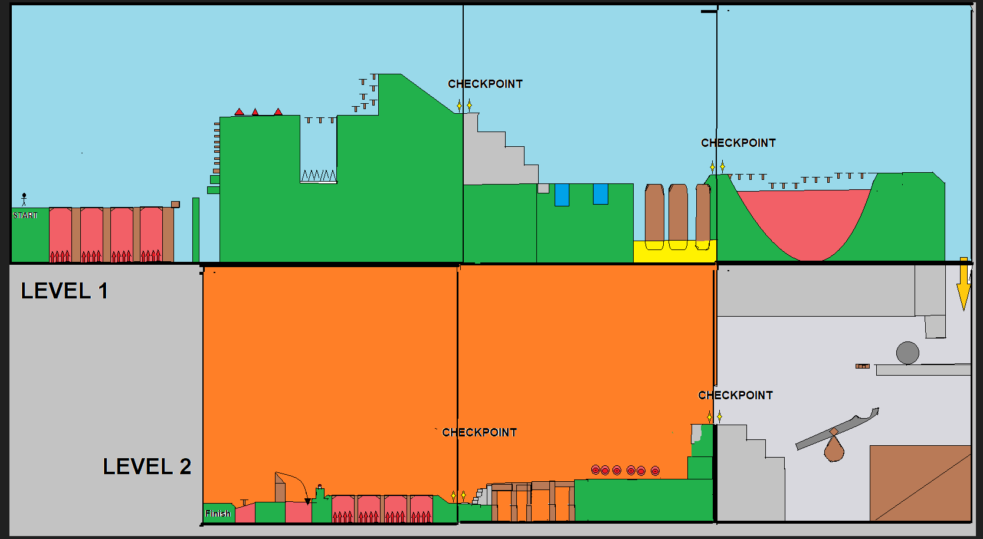
The additional sketch is different to the first one and the second one which is mostly a 2D version to 2.5D. the level one part of the map is the physical mode, and the level two is part of the hell zone transferable from Earth. Where in the background is light blue (earth sky) the grey zone is going to transition into the hell zone and the ground is for fire as it burning hot around the player ideally. In each sector, there is a checkpoint with one star and the other star which will end from one point of the level to the next. Which is an auto-saving part so if the player dies it will start at the position. So, when the player must go right my idea of the camera is a follow the player along with it. So, the player can't go back as this is a time-limit section across the map as it's very limited routes for the player to explore around the areas. In this sketch, the player's movements ideally are control movements such as w to jump or double jump for repeating “w” “w”.
Level 1.
Figure 1.
In Figure 1, The player starts where the “start” below the stickman is standing. Once the player clicks a button such as “start” both player and camera start the movement from left to right. The player must run across the wooden flooring as there are spikes below (the hazard zone will reset the player if stand on it or jump it too late). the player then jumps across from the wood rises platform to get to the safe green area (grass where it is safe to land)

Figure 2.
In Figure 2, The player must jump twice to reach the ladder and then jump over the different spikes and then the player must jump on the springboards to reach the other side without falling off them if so, another different type of spike (the hazard zone will reset the player if stand on it or jump it too late). after that, the player must jump on several springboards to reach the top. Then the player slides down afterwards to reach the end of this sector as there is a checkpoint.

Figure 3.
In Figure 3, After reaching the checkpoint the player must go downstairs and jump over the river (blue) and then jump over the platform safely, which is at the bottom of the platform there is a fire where if the player stands on it too late it will be destroyed (another hazard zone). Another checkpoint is if the player reaches the end of this sector of the level. Afterwards, at the checkpoint, the player must jump in a timely fashion to reach the ending the lake. The lake was made with lots of blood where ex-players will die in boiling water which is another hazard zone part.

Level 2.
Figure 4.
In Level 2, Figure 4 at the end of this sector, the player jumps into the unknown, but it is facing a big ball to push with as the ball gets closer to the edge there is a see-saw to make the rock ball balance so the player can to jump on but another hazard zone if the player stands on it or miss time it to reach to the stairs and reach the checkpoint.

Figure 5.

Next checkpoint, the player jumps down and runs across, but it has a timer that shoots arrows (hazard zone) at the player if the player gets hit the player will die and restart at the last checkpoint if the player gets the timing of the arrows, then the player can be able to reach towards the uneven bridge and then went down the stairs to reach the another checkpoint.

Figure 6.
Finally, at the end of Level 2, which is almost the ending of the game itself, the player runs up the small hill, the player must run across the wooden flooring as there are spikes below (the hazard zone will reset the player if stands on it or jump it too late) then the player touches the button to make the drawbridge to go down to jump on if the player didn’t touch the button the player will die if the player tries to walk with the drawbridge (hazard zone) and it will be reset it to the latest checkpoint. When the drawbridge goes down the player across it and jumps towards the springboard and then finishes at the end of both levels. The end.
Overall final map design
As the following sector is designing the final map for my 2.5D, I can design these onto Unity as a prototype for Eternal Crossin. The following images break down the final design as described in steps as the definitive version for example different sectors of the map are broken into small sectors, therefore I know what with good planning for the level map.
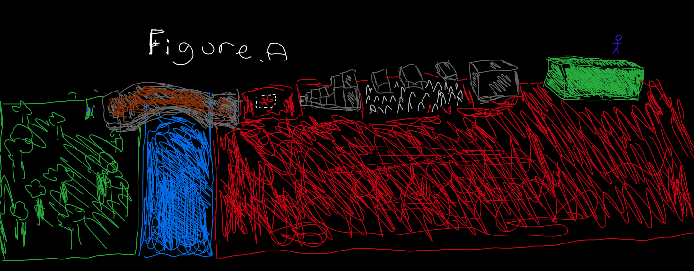
Figure A
At the beginning of the level, where the player starts in the green zone there is a stickman illustrating the player so the player can move from start to finish of my demo 2.5D. The player must move towards the edge of the start point, then the player must jump to reach the cube which is safe (a hazard zone) if the player misses the timing of the jump the player will fall and reset to the beginning of the level as the red is visible as it hot (ideally the flames and lava-like smoking and slipping hot flames out).
The player must jump onto the cube and then walk across the wooden platforms where it has automatically disappeared (hazard zone) where the player cannot see as the reference such as the “Leap of Faith" trap. Soon after that, if the player misses the jump or walk too slowly. The wooden platforms will disappear under the player, furthermore, the player will die and respawn at the beginning of the level. If, the player completes by reaching the other side of the wooden platforms. The player walks down the stairs, as well as the player placed by putting the character weight without clicking any keys on the keyboard as this is a trigger point where a platform to jump over to reach the bridge if the player doesn’t do this the player can’t reach the platform(a hazard zone) if the player miss timing of the jump the player will fall and reset to the beginning of the level as the red zone is hot.
Therefore, the player moves across the bridge if the player has done it correctly, under the bridge is water which is a hazardous placement where the player will drown goes back to the beginning. Afterwards, the player goes to a jungle area in this sector with trees etc, so the player moves around the area to reach the next part of the level.
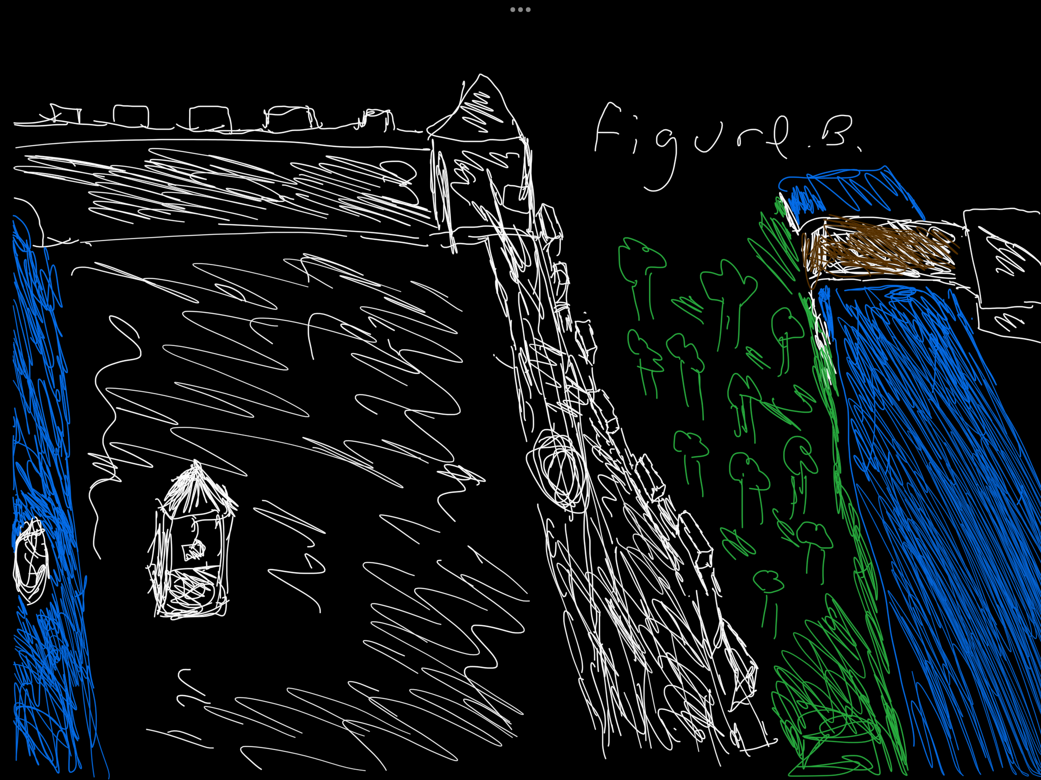
Figure B

The player moves towards the ruins of a castle; the player goes into a big hole in the wall of the ruin. The player moves towards the well afterwards the player must walk on the rocks to reach the next sector of the map.
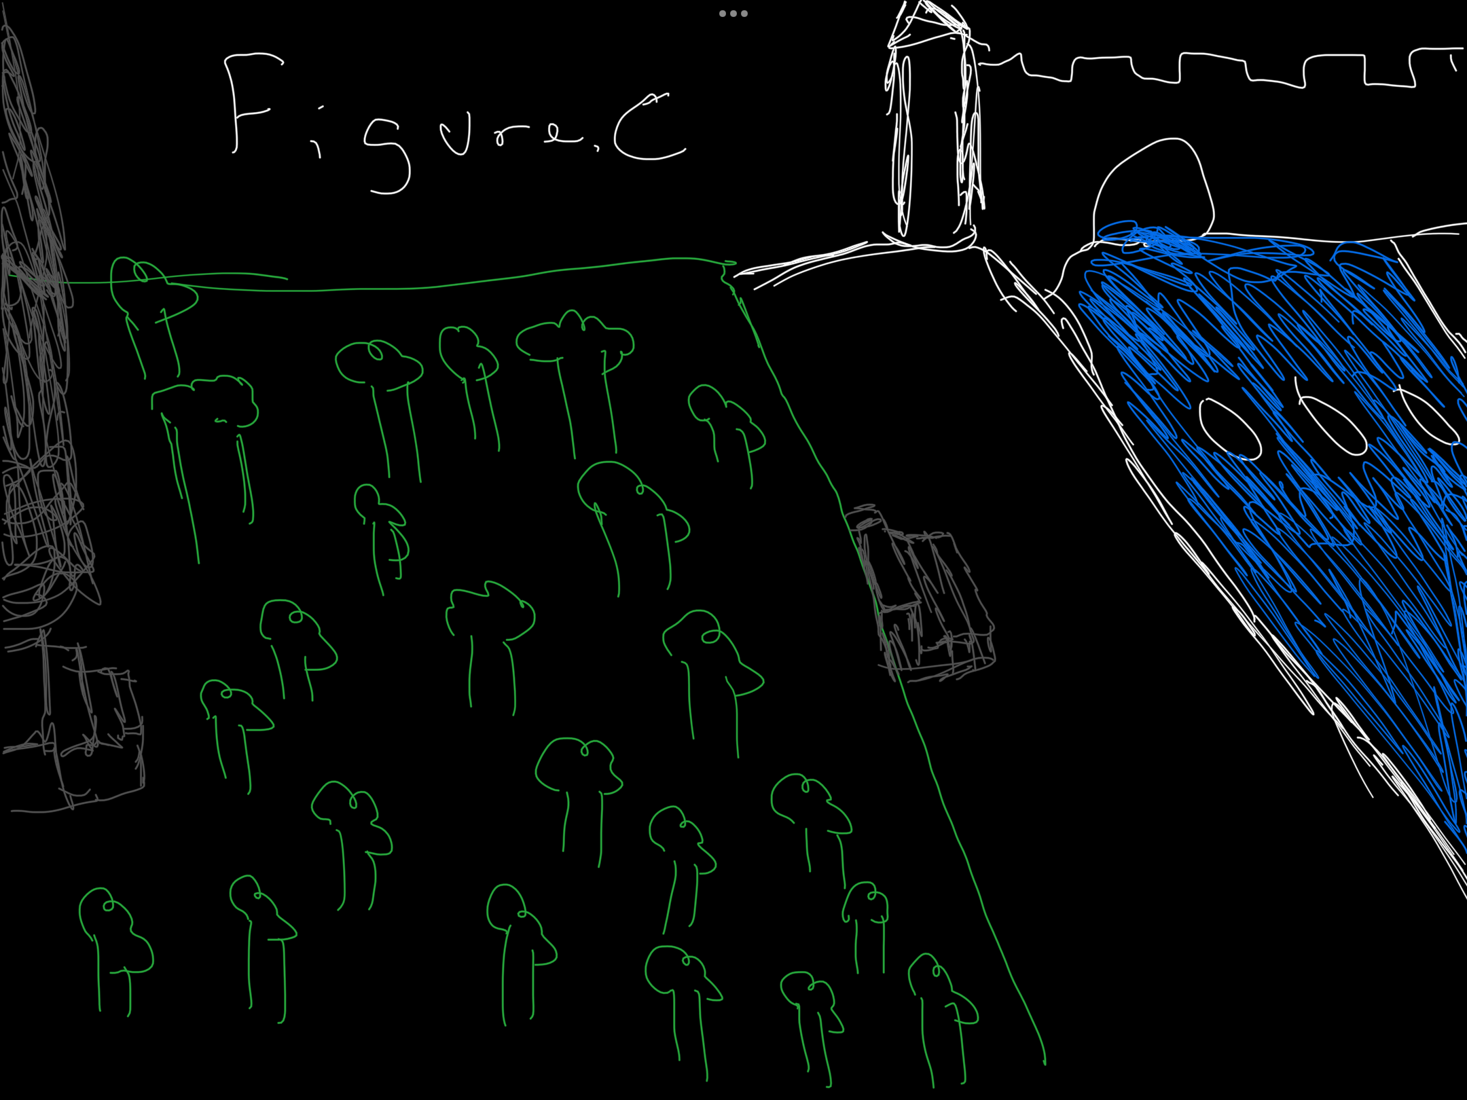
Figure C

The player jumps onto the rocks afterwards in Figure B. Then the player walks towards the stairs where ideally this part of quite high that the player cannot be able to reach and grab onto the ledge. When the player goes up the stairs where this is designed is a bordering abandoned garden of the ruins of the castle. ideally, a maze of trees to control the player to reach the stairs to reach the next sector of the map.
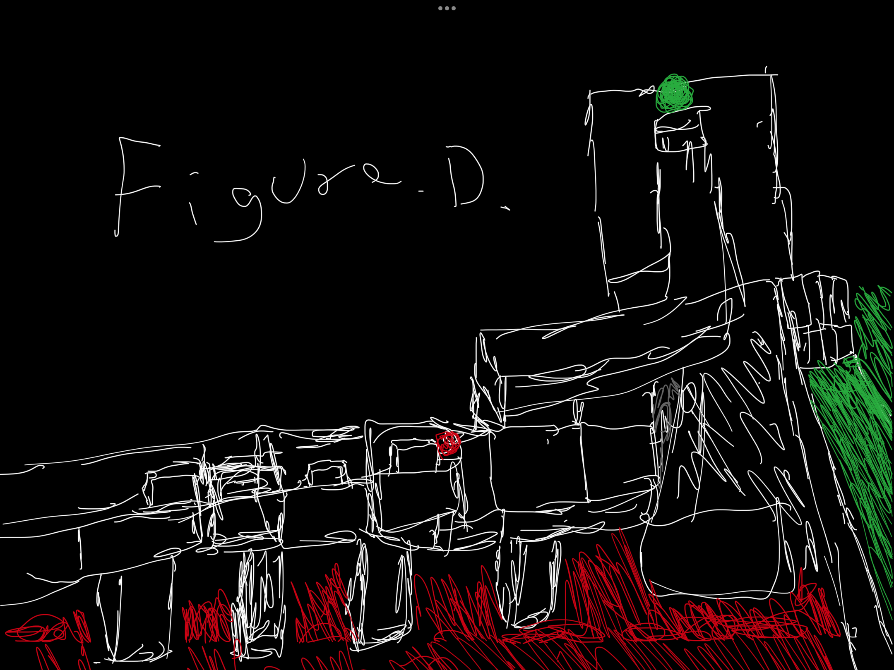
Figure D
Once the player, reaches the end of the last part of the maze the player moves towards a different place of this sector of the map the player walks up the stairs then the player walks thought-out a hole in a wall where the player continues walking the partway, but there is a trigger point. At the same time, different mechanics trigger a big ball as well as a cat-and-mouse chase scene. Where the player must move to reach the next sector of this map.
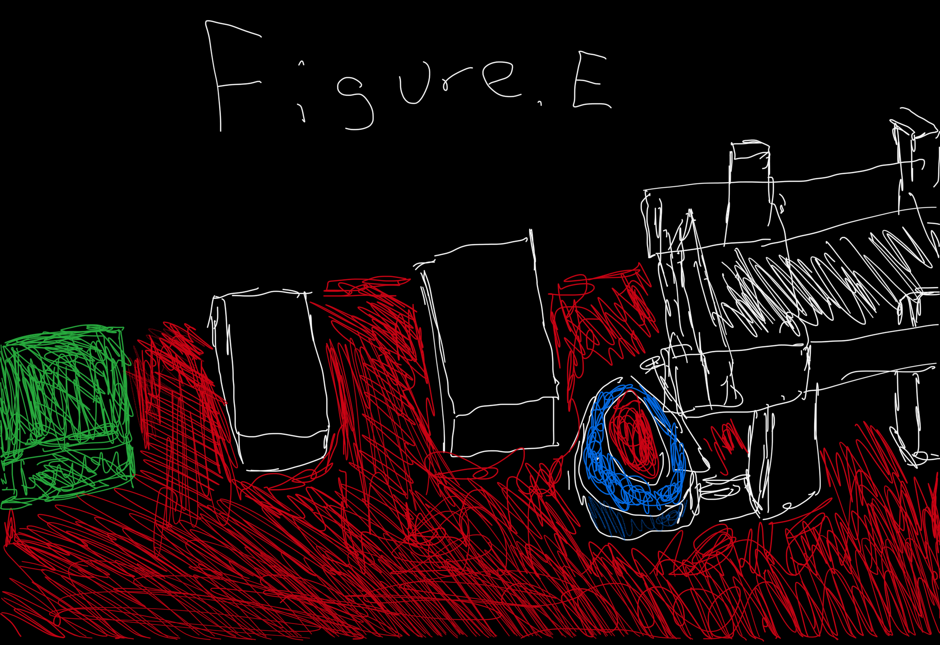
Figure E
I am focusing on this part of this level is the final jump mechanics. The player needs to reach the cubes before the big ball reaches the player. Afterwards, if the player jumps over from the edge of the semi-high platform to reach the other platform and then jumps over to the next platform (hazard zone under the platforms) then the player essential to jump to the green zone where the player reaches the ending of this level. The end.

Final - Map Design
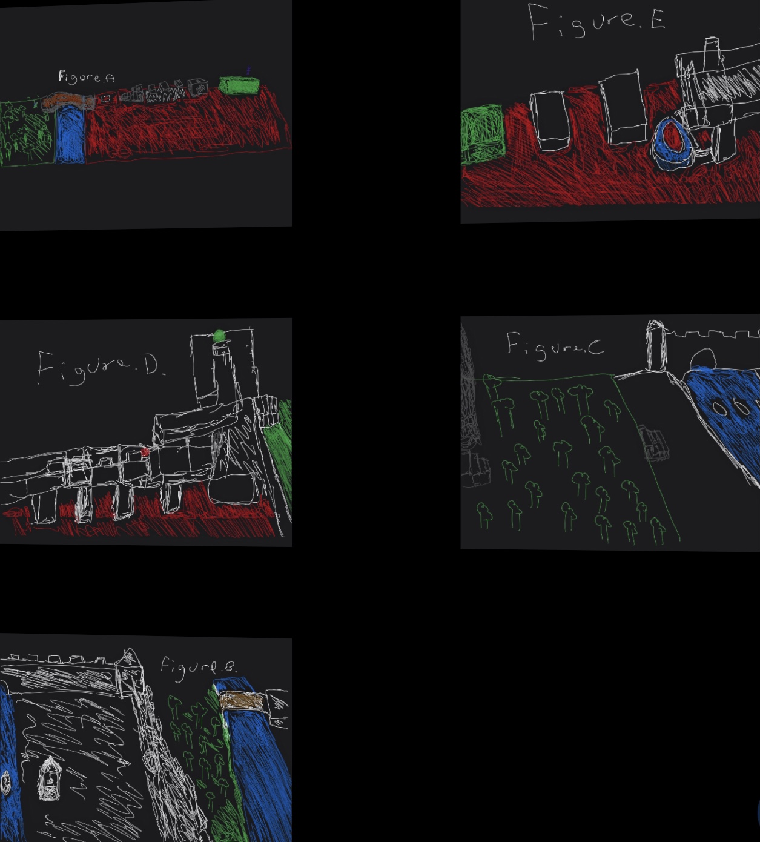
In my final level design, my final 2.5D game design concentrated on making a single, level map which is been used from different checkpoints such as in my first level design is into sectors so that prioritises jumping and avoiding hazards. The dynamic architecture of this level, which is full of obstacles like spikes, and shifting platforms, pushing buttons, is chased by a big ball that has been required by players to have fast reactions and correct timing. This map promotes exploration and experimentation more than my earlier designs, which felt more linear and uninteresting with complex puzzles or jumps. This level is elevated by the combination of visually stunning settings and difficult gameplay, creating a unique experience that attracts the players and keeps them alert.

Figure.1
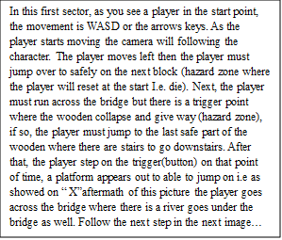
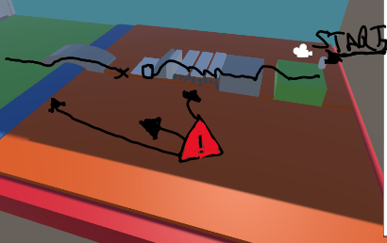

Figure.2
In Figure 2, the player walks to the entrance of the ruined castle, as for the green area and grey zone which is safe for the player. Ideally, I need to redesign this see this below in my logbook such as adding in trees etc.
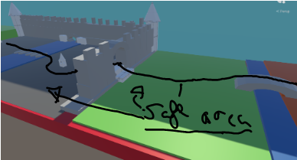
Figure.3
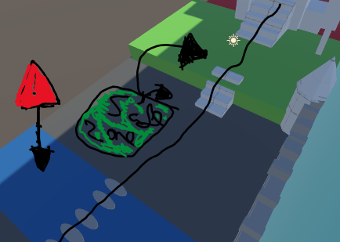
Figure.3 As the player continues throughout the layout of the castle’s ruins. The player must jump over the rocks to the other side as this is a hazard zone where the player reset to the last checkpoints in the game. Then throughout the grounds, the player walks up both stairs (need to add trees)
Figure.4
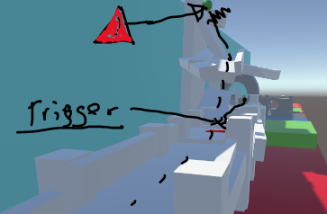
Figure 4, is about the end of the level, the player goes through the tunnel and walks down to nearby the red button (which is a trigger while the player is walking or running the big green ball rolls downhill (dash lines) as for this the cube will disappear to catch the player off guard
Figure.5
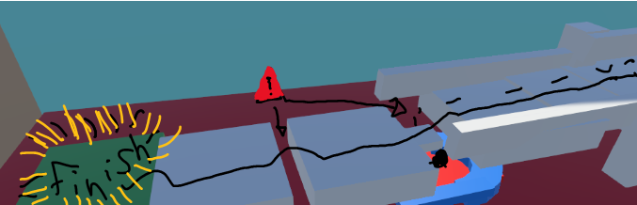
In this final figure.5 showing, the player must continue running to reach the next platform to be safe and the ball will go down If the player time it right. The player then jumps over the blocks which is safe for the player (in-between between the blocks there is a gap where the player must jump over and therefore the player at the finish. The end of the level.

Discussion of what the player is intended to experience and what choices and alternate routes are allowed
Choices/Alternate Routes setting in my 2.5D video game
- Multiple Pathways: Introducing different routes via a map can boost replay values and player control. For example, in a stealth game, a player may have to pick between a well-guarded main passageway and a series of hidden vents to reach their objective.
- Dynamic Environments: ideally to enable players to interact with the environment in ways that influence their route can lead to major choices. In a puzzle game (like my 2.5D), a player has the option to flood a chamber to reach higher platforms that will or not affect the map's navigability.
- Consequences and Outcomes: Choices must have consequences for the game world or narrative. In an RPG, choosing to side with a certain faction could reveal some regions of the map while closing others, affecting the plot and potential missions.
Example Scenarios
- Example 1: Open-World Exploration
  - Experience: Freedom and discovery.
  - Choices: Participants can choose to trail the key quests or explore side paths for hidden treasures and experiences.
  - Routes: The map includes several biomes like deserts, forests, and mountains, each with unique challenges and rewards.
- Example 2: Linear Story-Driven Level
  - Experience: Intense, focused narrative.
  - Choices: Dialogue options with NPCs that affect character relationships.
  - Routes: While the path is mostly linear, players can choose different approaches in combat, like stealth versus confrontation.
Logbook
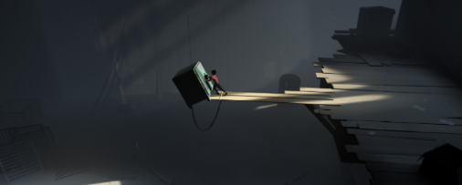
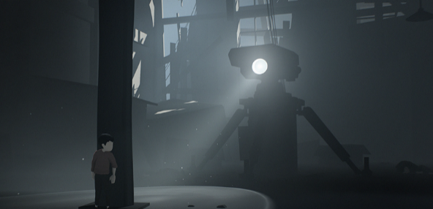
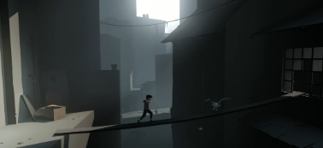
Initial Concept and Planning - Key Changes
I researched different types of 2.5D for the game concepts and the core mechanics list of games that I have looked at inside, and I learned how the target platform and audience work with them by watching trailers and walkthroughs of the game.
3/1/2024: 1st-Level Design (Paper Version)
Today I got a pen and some paper then I created my first draft of see picture as level 1.1, which I cut into different levels like moving to another part of the world in my game prototype
- Redesigns:
  - I added colours for the first level to know what I wanted to design.
5/11/2024: 2nd & 3rd - Level Design
Redesigns:
  - I added colours for the 1.2 level to know what I wanted to design.
In the final level, I draw out the player slides down into this section where there is a chase scenario wherein the player must run away from the ball that is behind the player (another hazard) and jump over some wood planks (odd ones which are another hazard sector) and then the rocks after that.

Redesigns:
  - I added colours for the 1.3 level to know what I wanted to design.
7/11/2024 to 10/11/2024: The second sketch idea (Aisome Apple App)
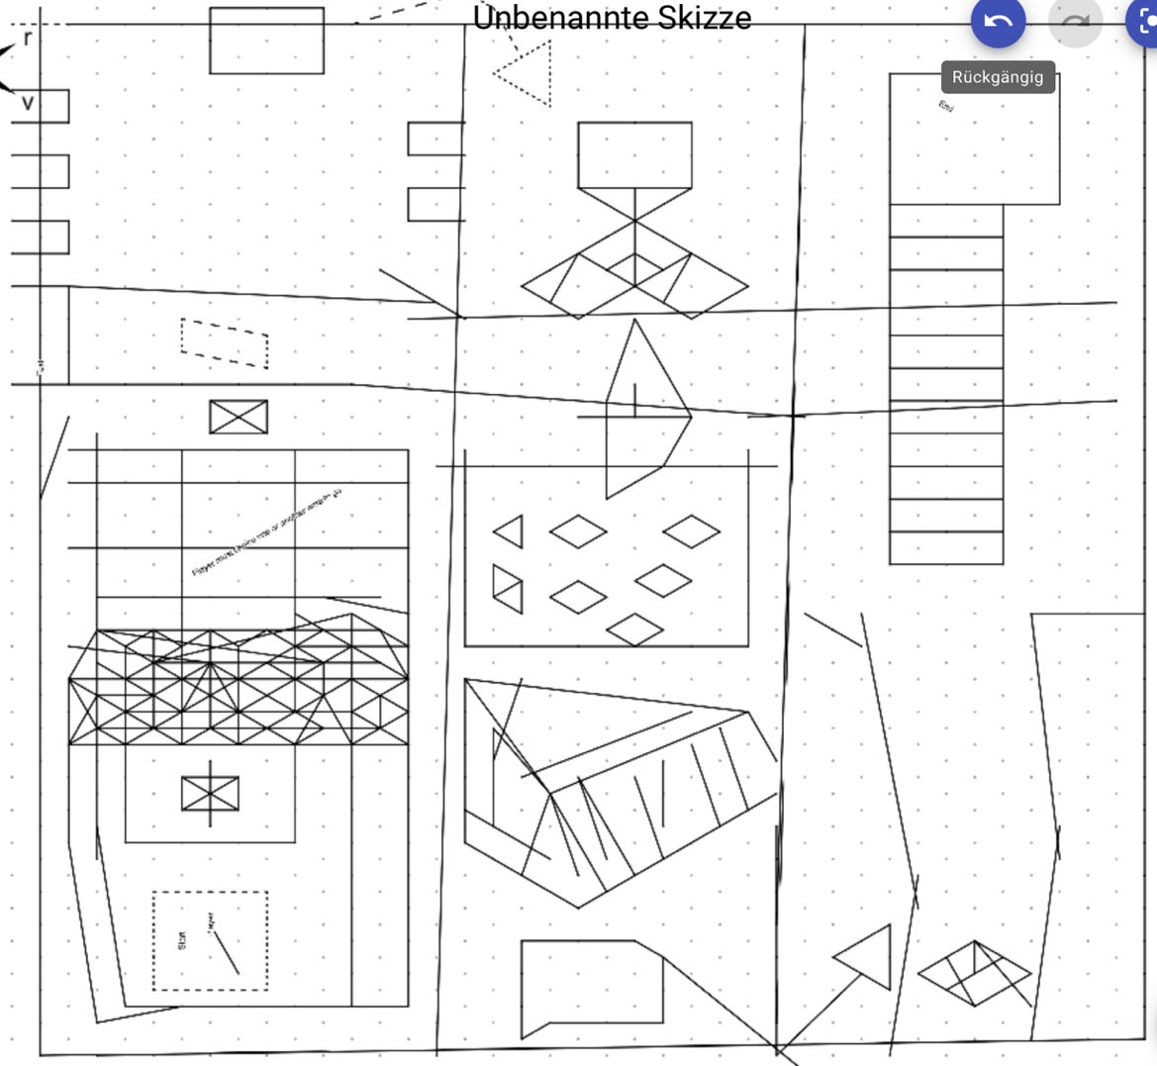
I use my iPad to design as an outline of the design that is quite like the paper version but other hazards that I can use like a fire spitting out of the small tunnel for example. I use the isometric paper which is only for the iPad which is quite useful and future designs or prototypes.
Redesign
- For the redesign part, I make the map without any colour. Next, I focus on the colour or redraw it as a whole

14/11/2024: The third sketch idea (paint)
For this third sketch that I designed, I used the Paint app on my computer, so it is another idea for my 2.5D with other triggers, spikes, and some other design mechanics that I could use for my 2.5D game as a prototype. As it has all been done most of the day to night where I spent time designing this and I find it quite easy to know what design in as appropriate.
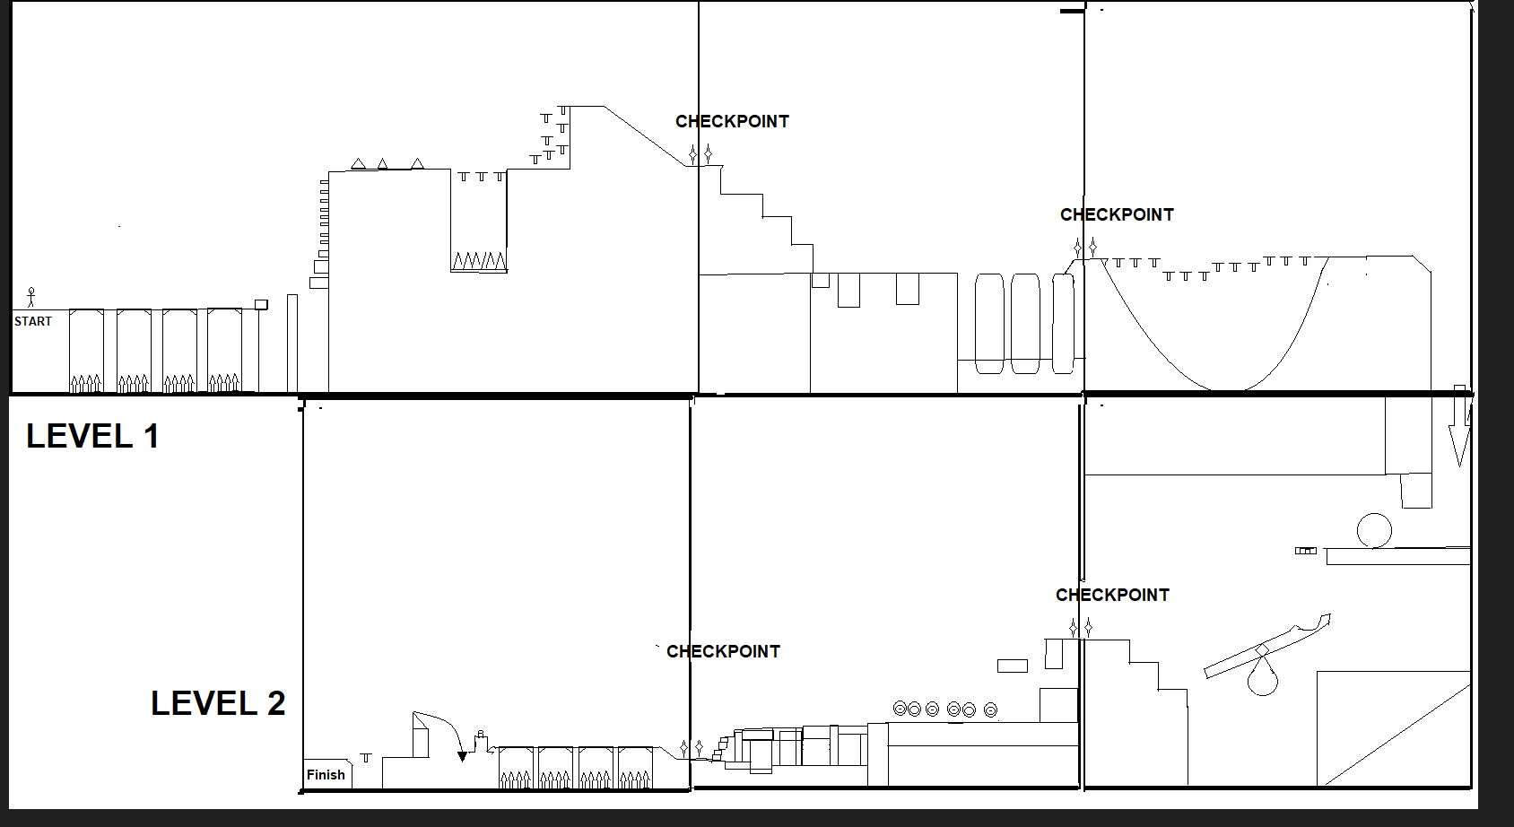

Redesign
  - I added some colour to know what to do for my game prototype for 2.5 D. as seen at the next top page.

26/11/2024: Final - Map Design
I use an app on my iPad called Pieces of Paper where I finally designed my 2.5D video game as a 2.5D drawing design where I designed everything such as an outline of the layout of the final map.
For the redesigning processing that I need for the finish and 2.5D game prototype. There are:
- Reprogram, the spikes so this is a hazard vs the player
- Aftermath of the bridge sector, I need to add such as some forms of displays of small, and big plants, trees, and other forms of natural materials to put into that sector.
- Added clouds that move in the background and when its hell sector changes colour to red
- Able to program in the ball so the trigger will work when the player steps on and the ball

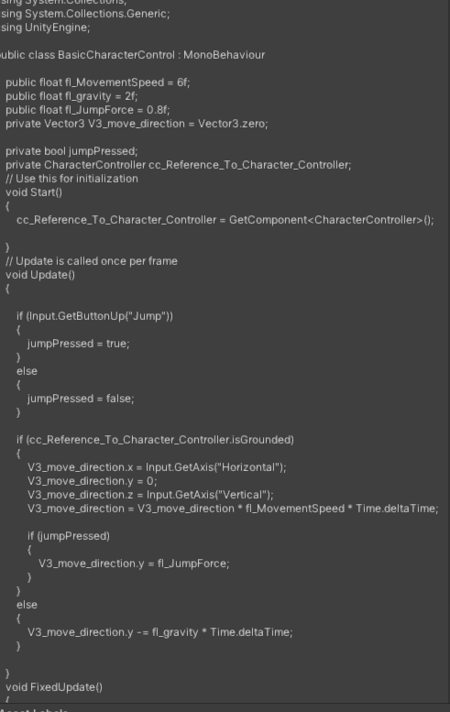

In Unity, specifically in my 2.5D game, there are several ways to manage basic movement in a game or video game simulations. A common way is to use a script with variables for speed, acceleration, and direction. In this script, I am focusing on the player character in a smooth control by using either the arrow keys or WASD and the jump button (spacebar) as input. For example, connects axes and input actions to the appropriate functions. This enables the game to process character actions from player inputs (such as keyboard or controller). i.e. Reference_To_Character_Controller.isGrounded

Feedback
Peers recommend the fading bridge mechanic as a useful element for understanding the control
Mechanism.
It is simple, and easy to manage, with simple movements and jumps.

Program
the code is well-layered and easy to grasp. It effectively uses its intended purpose and overall, as well the programming is good. There are attempts at reliable programming, although there are some hitches here and there. Walking on the river, for example, may resurrect me, but can walk on it most of the time. Furthermore, respawning, checkpoints, and other features do not yet operate.
The difficulty level
not severe, but the withering bridge takes too long to evaporate. It could have passed it and moved on to the next region if it had disappeared sooner. It is now too easy, as can move around the level freely.
The level layout
It appears to traverse through a ruined castle. The level is simple and effective in conveying what is wanted.
The feeling?
Overall, found the map to be a bit barren, with big mechanics that seem insignificant in comparison to the rest of the map. It felt tranquil as if walking in a park.
What about the product?
This is a good beginning to something bigger as it is believed there is potential in the idea and concept, but it is hindered by scale overall.
The level is well separated; however, it appears too large for what is now on screen.
What level of quality are looking for
Working 3/5 - bridge falls but is slow - rock path makes the player hover a few feet off the air
Enjoyable 3/5 - It was an enjoyable experience but was very empty
Exciting 2/5 - The most existing part of this experience was the falling bridge but since it's more than possible to cross before the first plank vanishes dulls the experience
The strengths of the game itself?
- The world theme is great.
- The mechanics are well-executed, and as the player goes,
- The gain a better understanding of the universe.
- The ideas established have great promise.
- The falling bridge adds to the map's theme, and the movement is smooth and free of stutters.
- The level is neat.
- The colour coding for the level gives a sense of advancement.
- The level elements' forms are various.
- The scripts work when they need to.
Weaknesses of the game itself?
- The map was too large for the mechanics and player, creating an empty feeling. The bridge took too long to fall.
- The main mechanics (bridge) were too small and felt like they could be easily walked over.
- The camera was too far away, making progress feel slower.
- The player felt like he was made of lead and would fall hard whenever the player jumped.
- Scripts do not work consistently.
- The level is very straightforward.
- There are no difficulties.
- There are no consequences now for failure.
- The controls occasionally cease working.
What thoughts do have for this 2.5D design to perhaps improve the game?
Ideally, modify the scale of the map and adjust the assets to occupy more of the screen, as well as adjust the variables of components to make the character seem smoother to operate and the bridge feel that is a little more unsettling. As a recommendation expanding the planet out a bit more to make it feel less bleak to future gamers. Maybe, this would change the size of the level to provide a faster pace to the game or add more between mechanics in the centre of sections.
Reflection
Reflecting on the feedback that I received for my 2.5D game, I can see that while it has certain qualities, there are also parts that need to be improved a great deal. The feedback highlights that the game is basic and easy to play, with straightforward movements and jumps while it makes the game more accessible and appealing, it also risks making the experience feel unchallenging and clean. The programming part has been highlighted for being well-layered and simple to understand, while effectively serving the purpose it was created for. Although all of this, there are still gaps, such as some aspects like respawning and checkpoints not working properly. Feedback is very important for the capacity to walk on water and the delayed disappearance of the wilting bridge.
One of the key findings is that, while the level design properly portrays the intended theme of a ruined castle, it feels too broad for the present gameplay, resulting in an emptiness that distracts from the overall experience. The feedback suggests the surroundings feel at ease and park-like, which may not fit with the game's liked atmosphere. Furthermore, the recommendation to change the map's scale and camera angle shows a desire to make the game more engaging and active. To resolve all these issues, a more compressed and visually appealing environment may be created, with changes to make the bridge mechanisms more visible and impactful.
By improving these features and increasing the consequences of breakdown, the game could provide a fairer challenge. Finally, the feedback suggests there is a strong base with massive promise, and it seems that by addressing the scale and mechanics, the game might become a more engaging and pleasant experience for the player

Conclusion
Immersive gameplay in a 2.5D Game: - Key Aspects & Tasks
I intend to design my 2.5D video game-specific experiential and inspiration-based short-term goals to guide the development process. One of my realistic goals in making this game is immersive Gameplay: The game should provide an engaging and immersive experience, capturing players' attention with captivating gameplay mechanics. In building up the game world that I have designed, I focus on the core mechanics. When planning my 2.5D game, creating an immersive gameplay experience means crafting mechanics, visuals, and interaction systems that captivate players and draw them into the world you are building. 2.5D refers to a visual style where the game world and characters appear to be three-dimensional but operate on a two-dimensional plane. This is often achieved by using 3D models rendered from a fixed perspective, while the gameplay itself remains like a side-scrolling or top-down version. To ensure the game is engaging and immersive, several core aspects must be incorporated into both the design and mechanics.
Here is a breakdown of what should be considered and applied:
Engaging Core Gameplay Mechanics
My main goal is to keep players interested, the game needs mechanics that are fun, challenging, and rewarding. These mechanics should be easy to learn but difficult to master.
Key Tasks:
- Flowing Movement & Controls: The player should feel in command of the character, with simple movement and responsive controls. For my 2.5D game, the platforming must feel seamless and satisfying.
  - Task: Creating precise jump mechanics, dash movements, and gravity systems that respond reliably to user inputs from the real world like earth-setting
Puzzles: Include traps that flow naturally with the level design. These mechanics should advance as the game continues, adding depth and variety.
  - Task: to create dynamic puzzles that make creative use of in-game the laws of physics and more levels to challenge the player or opportunities for in-depth versions.
2. Immersive Visual & Audio Design
The visual and audio elements of the game contribute significantly to immersion. In a 2.5D game, the world should feel alive and visually engaging, with layers of depth and atmosphere that create a sense of place.
Key Tasks:
- Layered 2.5D Environments: Use depth in the backgrounds, foregrounds, and platforms to create the illusion of a 3D world while keeping the gameplay constrained to 2D. Lighting, shadows, and particle effects can add immersion.
  - Task: Design levels with parallax scrolling and subtle environmental animations (wind blowing, water flowing) to give the world depth and life.
- Cinematic Moments & Camera Angles: Even though the game is 2.5D in nature, dynamic camera movements can make the experience feel more cinematic and exciting.
  - Task: Implement camera transitions that zoom in/out, tilt, or rotate during key moments such as dramatic plot events.
- Sound Design or Music: Ambient sounds, environmental audio, and a well-composed soundtrack contribute to the emotional tone of the game. The sound should adapt dynamically to gameplay elements.
  - Task: Develop ambient sounds that correspond to specific locations (forest sounds, echoing caves) and create a soundtrack that evolves with gameplay progression.
3. Engaging Story & World-Building
A good plot can be drawn to players deeper into the game. Even in games with simple stories, the world can be rich in mythology and mood.
Key Tasks:
World Design: To create multiple environments that tell a story. Each level or section within my game should feel like it belongs in a bigger background. Small details (fire, smoke, water) can provide insight into the physical or afterlife between heaven and hell.
  - Task: Design levels with environmental storytelling elements that give players a sense of place and context without needing extensive exposition.

Inspiration-Based Goals

1. Art Style: Inspired by visual design, my game should have a unique art style that improves the gameplay experience.
2. Narrative Design: The narrative should be inspired by fascinating storylines to provide depth and emotional connection with the player and character.
3. Cultural or Genre Inspirations: I will use my video game, which might be based on different themes, like fantasy, sci-fi, or folklore, to develop a unique beyond or crossover with other genres.

Additions to the Current Prototype
- Adding new phases or environments can enhance the game's depth and replay abilities to be new features of the prototype.
- Improved graphics for better visuals and atmosphere.
- Adding fresh story twists or character developments to enhance the narrative experience for the player of my game

Changes for the next steps for my 2.5 video game prototype.
• User Testing Stages: Carry out throughout game-testing to gain feedback on gameplay and design components.
• Optimise in-game performance for smooth gameplay across devices.
• Set up a planned approach to leveraging player feedback into ongoing design changes, such as making them feel happy and enjoyable and making them look forward to the next DLCs or patches.
Overall, the success of the 2.5D video game prototype and areas for improvement will be determined by how well it meets the set goals, and the feedback received from players, which is very important. This can be engaged based on this feedback, which is essential for refining the game itself. That must be done to ensure it stays aligned with both experiential and inspiration-based objectives.
References
full bibliographic details of all sources used and cited
The Ankh, Joshua J. Mark (19 September 2016) Accessed on 06/11/2024 at: https://www.worldhistory.org/Ankh/
Eveliina Aalto Creating immersive 2D world visuals for platform games – Skytails Post-Mortem, [page 20]. Accessed on 06/11/2024 at https://aaltodoc.aalto.fi/server/api/core/bitstreams/ea399ff5-b23b-45f3-a010-03cef8c46844/content
Oksanen, K., & Hämäläinen, R. (2014). Game Mechanics in the Design of a Collaborative 3D Serious Game. Simulation & Gaming, 45(2), 255-278. Accessed on 06/11/2024 at: https://doi.org/10.1177/1046878114530799
video games can expand players' emotional range, helping their emotional development and giving a richer engaging experience. Shinkle, E. (2008). Video games, emotion and the six senses. Media, Culture & Society, 30(6), 907-915. Accessed at: 6/11/2024 https://doi.org/10.1177/0163443708096810
Britannica. (2014, April 21). at Perspective. Retrieved from Britannica: Accessed on 06/11/2024 at: https://www.britannica.com/art/perspective-art
Paths. Peculiar. (4AD) (4th January 2020) accessioned on 11/11/2024 at: https://www.instagram.com/p/B66MFhABDfB/
Serious Games. In: Dörner, R., Göbel, S., Effelsberg, W., Wiemeyer, J. (eds) Wiemeyer, J., Nacke, L., Moser, C., ‘Floyd’ Mueller, F. (2016).. Springer, Cham. Accessed on 06/11/2024 at: https://doi.org/10.1007/978-3-319-40612-1_9.
Playing with Cinema: The Development of audio-visual style in Video games. C. J. FROEHLICH.August 2023. Accessed on 17/11/2024 at: https://www.proquest.com/openview/76bfe93ea9600b7ac8fe955e7908df2a/1?pq-origsite=gscholar&cbl=18750&diss=y
Basics of Platform Games. Minkkinen Toni.August 2016. Accessed on 17/11/2024 at https://www.theseus.fi/bitstream/handle/10024/119612/Thesis%20-%20Toni%20Minkkinen.pdf

